**Analysing the difference between the custom model and the Keras model.**

This chart shows the difference in time between how long it takes to run a model. Here is the output of the models:

Keras Model without stride: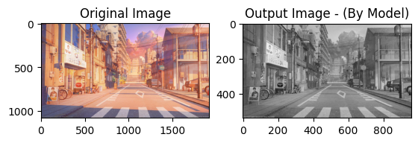

Keras Model with stride: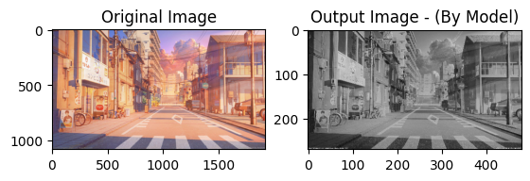

Custom Model without stride:

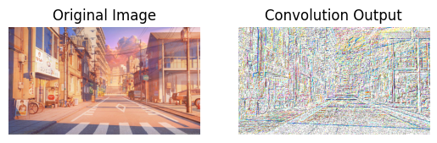

Custom model with stride:

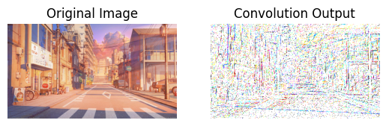

Output of single layer in custom:

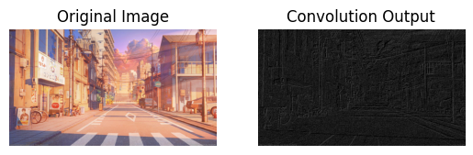

Although the custom model requires more time to complete than the library model, understanding the model's matrix multiplication is still beneficial.

The result may change based on the size of the images.